Data solar field Almeria :

* HTF test loop erected in 1997
* Oriented East-West
* 18 bar maximum for HTF
* HTF : Syltherm 800
* Facility include :
  + 1m³ expansion tank (with nitrogen inertization)
  + Oil sump tank
  + Oil cooler (max 400 kWth)
  + Centrifugal pump (8.3 liter/sec max)
  + Electric oil heater
* Data Solar field :
  + 75m long
  + 4 Eurotrough first generation/2 second generation
  + 6 modules 12-m long 🡪 72 m
  + 18 receiver tube
  + Net aperture : 409.9m²
  + Absorber tube : UVAC (Universal Vacuum Collector, Solel)
    - UVAC properties :
      * 70 mm OD stainless tube + coating
      * Tube wall thickness = 2 mm
      * 115 mm OD antireflective evacuated tube
      * Glass wall thickness = 3 mm
      * 0.013 Pa vaacum (avoid convection)
      * Glass envelope transmittance : 0.96 (0.967 according rioglass website)
      * Coating absorptance : 0.95-96
      * Coating emmittance 0.15 or 0.091 at 400°C
    - There are already correlations for Q_dot_loss/m for UVAC2 (see Burkholder) and UVAC3
    - More technical info on <http://www.rioglass.com/?page_id=1925>
    - Other info from Forristal
      * Glass absorptance = 0.02
      * Glass emissivity = 0.86

|  |  |  |
| --- | --- | --- |
| Eps1 – HCE shadowing factor | [-] | 1 (or Forristal) |
| Eps2 – Tracking error factor | [-] | 1 (0.98 Valenzuela ppt) |
| Eps3 – Geometry error factor | [-] | 1 (or Forristal) |
| Eps4 – Dirt on Mirrors factor | [-] | 1 (or Forristal) |
| Eps5 – Dirt on HCE factor | [-] | 1 (or Forristal) |
| Eps6 – Unaccounted error factor | [-] | To adjust (1 at beginning) |
| Rho_cl – mirror reflectivity | [-] | 0.94 ou 0.931 (Lupfert) |
| Tau_g – glass transmittance | [-] | 0.92 (From Pyrex datasheet, but higher values up to 0.96 achieved in other HCE) |
| Alpha_g – Glass absorptance | [-] | 0.02 (Forristal) |
| Eta_opt_0 – Optimal optical efficiency | [-] | 0.684 (Sallaberry) |
| Eps_g – Glass emissivity | [-] | 0.86 (Forristal) |
| Alpha_t – tube absorptance | [-] | 0.7986 (recalculated) |
| Eps_t – Tube emissivity | [-] | ? no idea …. |
| a_K (coeff IAM theta) | [-] | +- 4.11e-3 (Sallaberry) |
| b_K (coeff IAM theta²) | [-] | +- 5.513e-5 |
| L – length of one collector | [m] | 71.16 (Sallaberry = 409.9/5.76)  71.88 (Lüpfert = 6*11.98) |
| A_p – aperture of the parabola | [m] | 5.76 |
| Dext_g – external glass diameter | [m] | 0.12 (Javier) |
| th_g – glass wall thickness | [m] | 0.0025 (Javier) |
| Rho_g – glass density | [kg/m³] | 2230 (from Pyrex datasheet <http://www.qvf.com/glass-equipment/borosilicate-glass/physical-properties.html> ) |
| Cp_g – glass specific heat capacity | [J/kg.K] | 900 (from Pyrex data <http://www.qvf.com/glass-equipment/borosilicate-glass/physical-properties.html> ) |
| Lambda_g – glass thermal conductivity | [W/m.K] | 1.14 (from Pyrex datasheet) |
| Dext_t – tube external diameter | [m] | 0.07 (Javier) |
| th_t – tube wall thickness | [m] | 0.002 (Javier) |
| Rho_t – tube density | [kg/m³] | 7990 (Javier) |
| Cp_t – tube specific heat capacity | [J/kg.K] | 515 (average from Javier email) |
| Lambda_t – tube thermal conducitvity | [W/m.K] | 16.3 (<http://asm.matweb.com/search/SpecificMaterial.asp?bassnum=MQ316A> ) |
| P_atm – Atmospheric pressure | [Pa] | 1e5 |
| K_air – thermal air conductivity | [W/m.K] | 0.025 |
| Rho_air – air density | [kg/m³] | 1.17 |
| Mu_air – air dynamic viscosity |  |  |
| Pvaccum – vaccum pressure | [Pa] | <113 Pa (1torr) |
| Gamma – ratio of specific heats for the annulus gas | [-] | 1.39 |
| Delta – Molecular diameter for the annulus gas | [cm] | 3.53e-8 (Forristal) |
| BB – interaction coefficient | [-] | 1.571 (Forristal) |
| K_st – thermal conductivity at standard pressure and temperatur | [W/m.K] | 0.02551 (Forristal) |
|  |  |  |
|  |  |  |
|  |  |  |
|  |  |  |
|  |  |  |
|  |  |  |
|  |  |  |
|  |  |  |
|  |  |  |
|  |  |  |
| CA022 |  | Potentatia del indfirador en kWh |

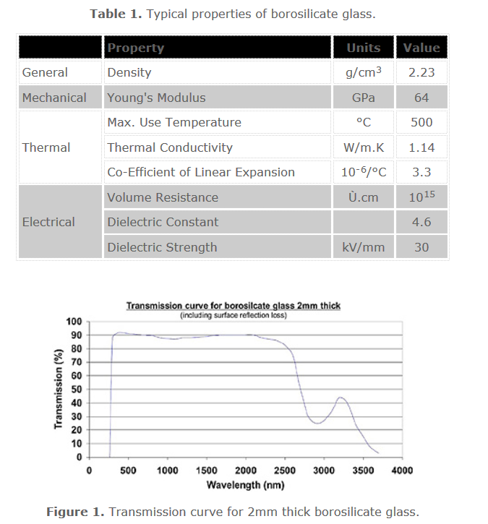

<http://www.azom.com/article.aspx?ArticleID=4765>

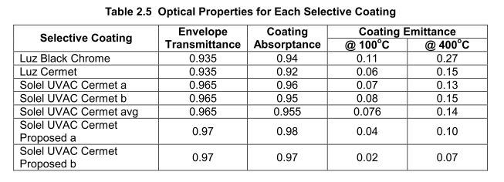

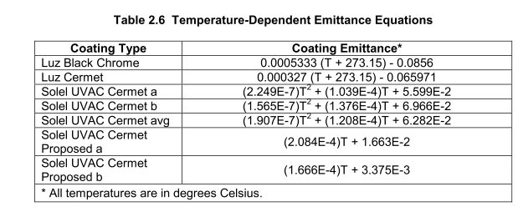

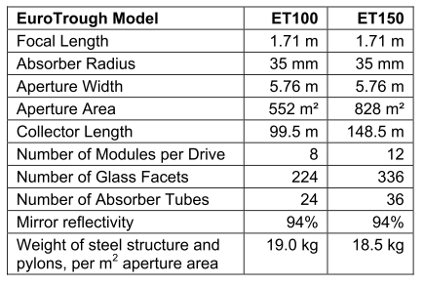

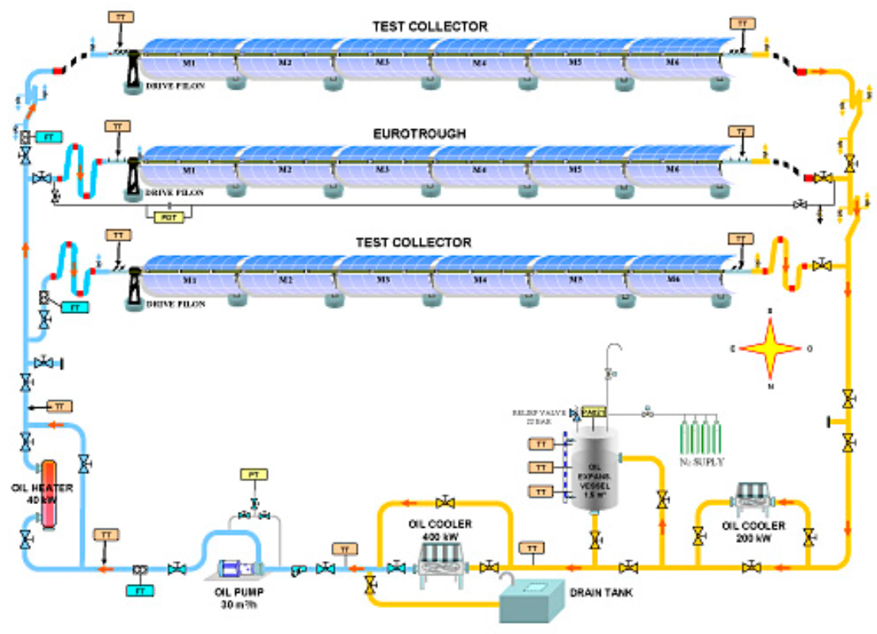

Source : PSA website

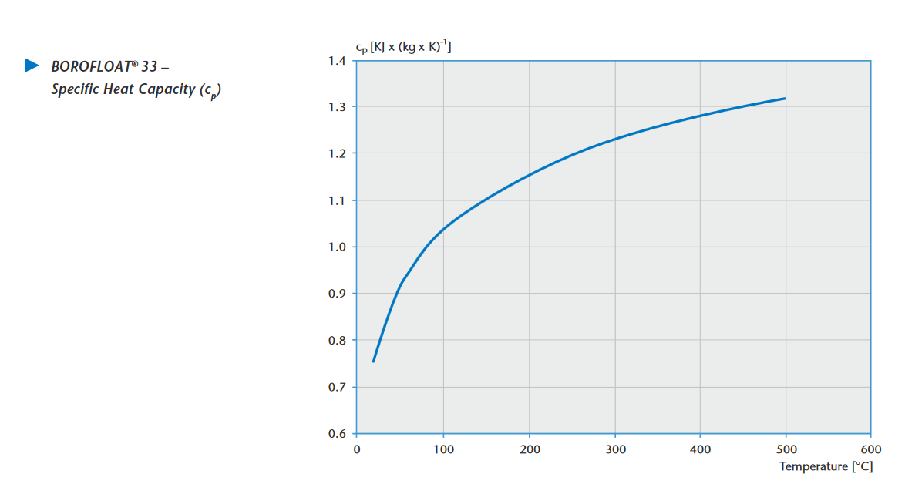

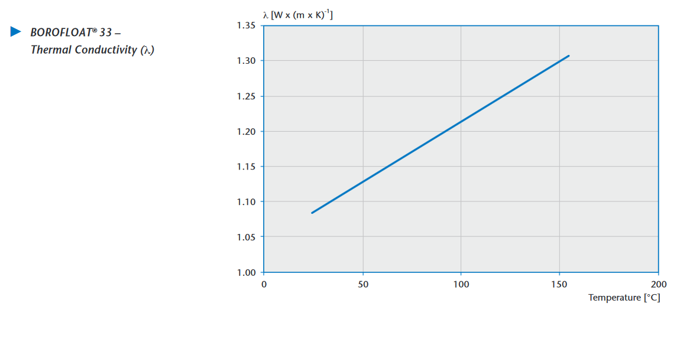

UVAC 1 and UVAC2 curves

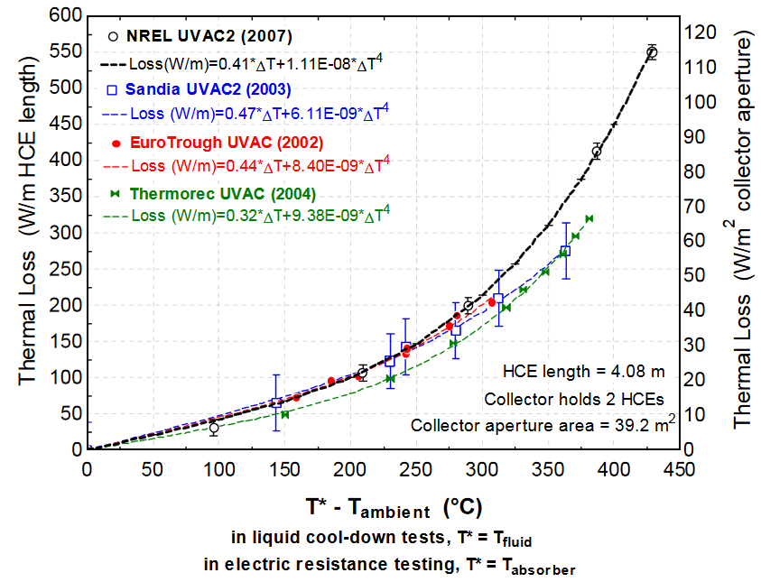

Source : <http://www.nrel.gov/docs/fy07osti/41423.pdf>

UVAC 2 curves

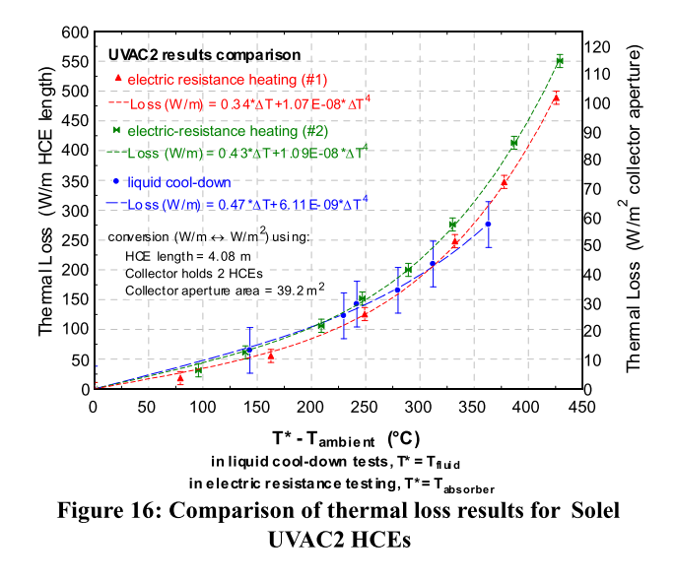

Source : burkholder (PTR testing)

UVAC3 and UVAC2 curves

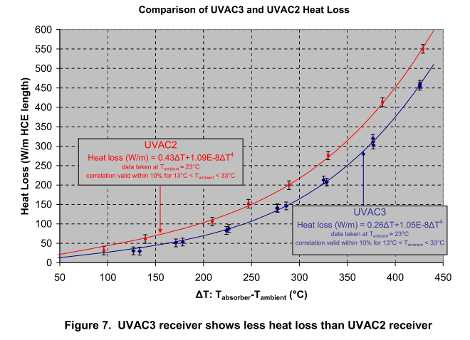

Source: burkholder UVAC3 report

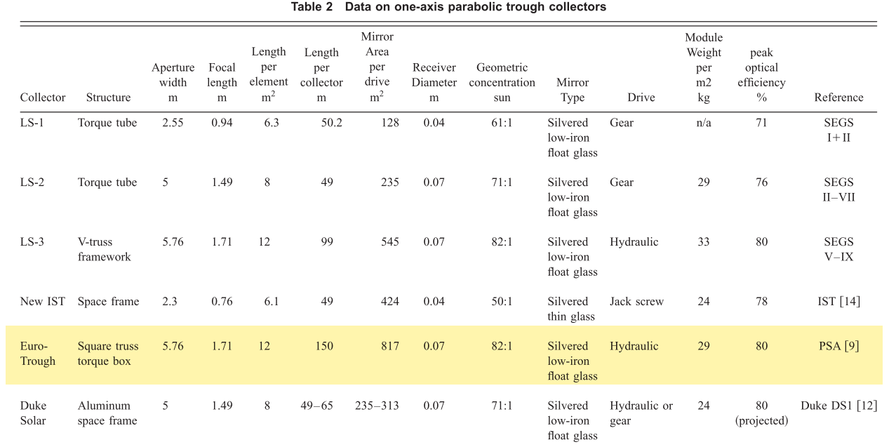

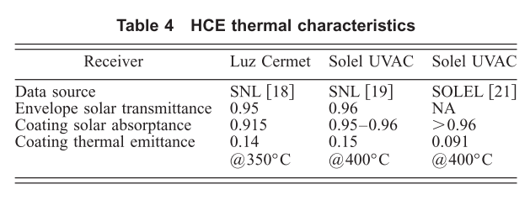

Source : Price

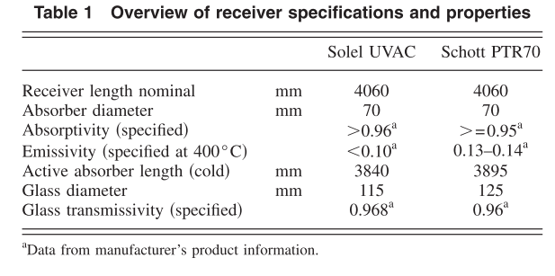

Source : lupfert